**PROJECT DESCRIPTION:**

The simulation project comprises of 7 Simulations for different datacenter configurations.

Simulation 0 to Simulation 3 has map reduce implemented on one datacenter i.e. both mappers and reducers are implemented on the same datacenter; while for the simulations Simulation 4 to Simulation 6, map reduce has been implemented on different datacenters.

**CONFIGURATION DETAILS:**

**Simulation 0 - Simulation 3**

|  |  |
| --- | --- |
| Number of Datacenters | 1 |
| Number of Mappers | 4 |
| Number of Reducers | 2 |
| Number of VMs | 5 |
| Number of Hosts | 1 |
| Cost of Operation Per Sec | 3.0 |
| Cost Per Memory | 0.05 |
| Cost Per Storage: | 0.1 |
| Cost Per Bandwidth | 0.1 |
| VM Scheduling Policy | Time Shared |
| Cloudlet Scheduling Policy | Time Shared |
| Network Bandwidth | 10 |
| Network Latency | 10 |

**Simulation 4 - Simulation 6**

|  |  |
| --- | --- |
| Number of Datacenters | 1 |
| Number of Mappers | 4 |
| Number of Reducers | 2 |
| Number of VMs | 5 |
| Number of Hosts | 1 |
| Cost of Operation Per Sec | 3.0 |
| Cost Per Memory | 0.05 |
| Cost Per Storage: | 0.1 |
| Cost Per Bandwidth | 0.1 |
| VM Scheduling Policy | Time Shared |
| Cloudlet Scheduling Policy | Time Shared |
| Network Topology | Mesh |
| Network Bandwidth | 10 |
| Network Latency | 10 |

**OBSERVATION:**

**Simulation 0:**

The VM allocation policy implement is “Simple Allocation”. Execution results are as mentioned below.

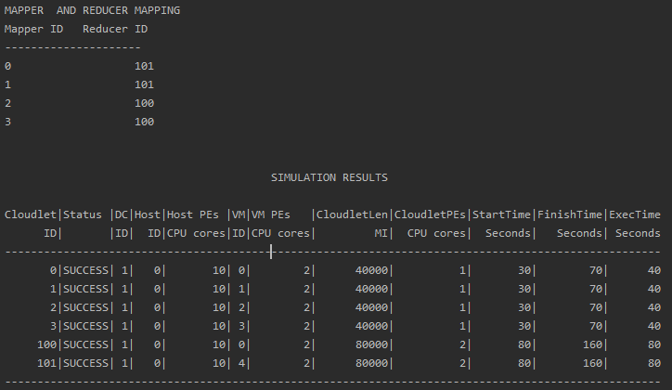

**Simulation 1:**

The VM allocation policy implement is “Round Robin Allocation”. Execution results are as mentioned below.

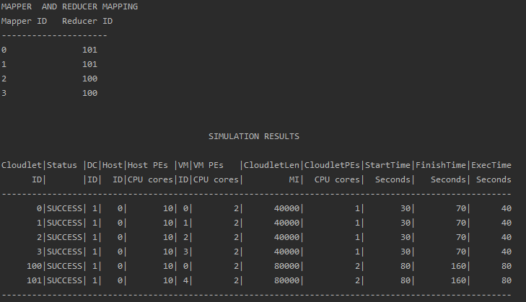

**Simulation 2:**

The VM allocation policy implement is “Best Fit Allocation”. Execution results are as mentioned below.



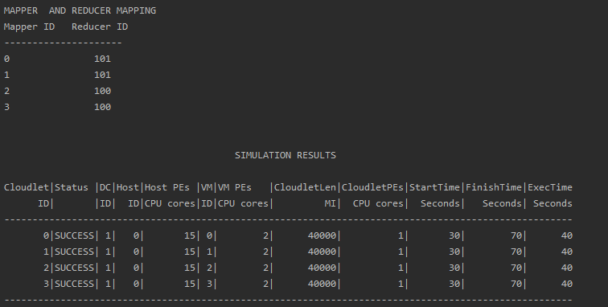

**Simulation 3:**

The VM allocation policy implement is “Worst Fit Allocation”. Execution results are as mentioned below.



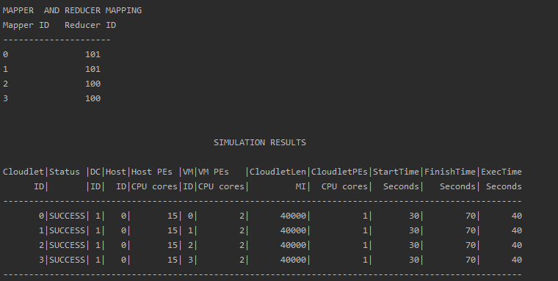

**Simulation 4:**

The VM allocation policy implement is “Round Robin Allocation”. Execution results are as mentioned below.

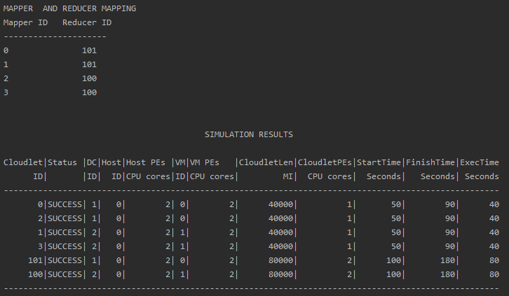

**Simulation 5:**

The VM allocation policy implement is “Best Fit Allocation”. Execution results are as mentioned below.

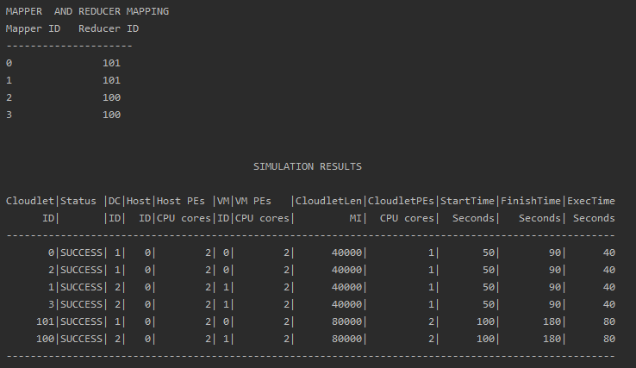

**Simulation 6:**

The VM allocation policy implement is “Worst Fit Allocation”. Execution results are as mentioned below.

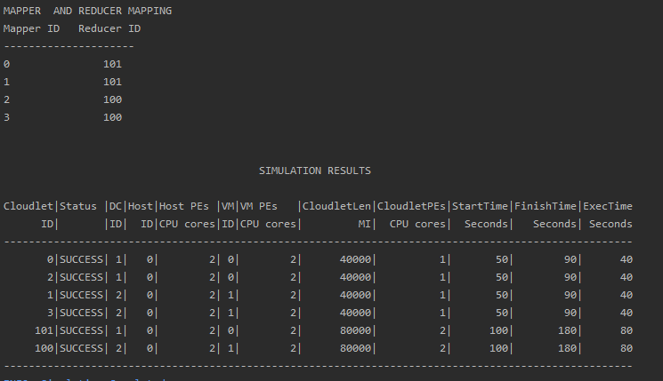

In the simulation 0 and 1, the simulations run perfectly fine. While in the simulations 2 and 3 for the same configuration, the scheduling of VMs to the host failed due to memory or storage insufficiency. Thus, we conclude that Round Robin and Simple Allocation policies are better than the Best-Fit and the Worst-Fit allocation policies. We also observe that placement of mappers and reducers on different datacenters affect the start time of execution of the reducers. There is a delay involved due to overhead of communication between the datacenters,

**MAP REDUCE IMPLEMENTATION DESIGN:**

The architecture of the application consists of Mappers and Reducers and a Master to coordinate execution of mappers and reducers. Mappers and Reducers have been implemented by extending the *CloudletSimple* Class. *Master* class maintains a Hashtable *mapperReducerMapping* which includes mapping of Mappers and Reducers in the system. The application has been designed such that every reducer is mapped to two mappers. Every Mapper is bound with *addOnFinishListener()* listener which is invoked on the completion of execution of each Mapper. This listener includes invocation call to the method *executeReduce ()* which spawns the creation of corresponding Reducer. The newly created Reducer is submitted dynamically for execution. Depending on the configuration, the reducers are either submitted to the same *Datacenter* as that of mapper or is submitted to a different *Datacenter*.